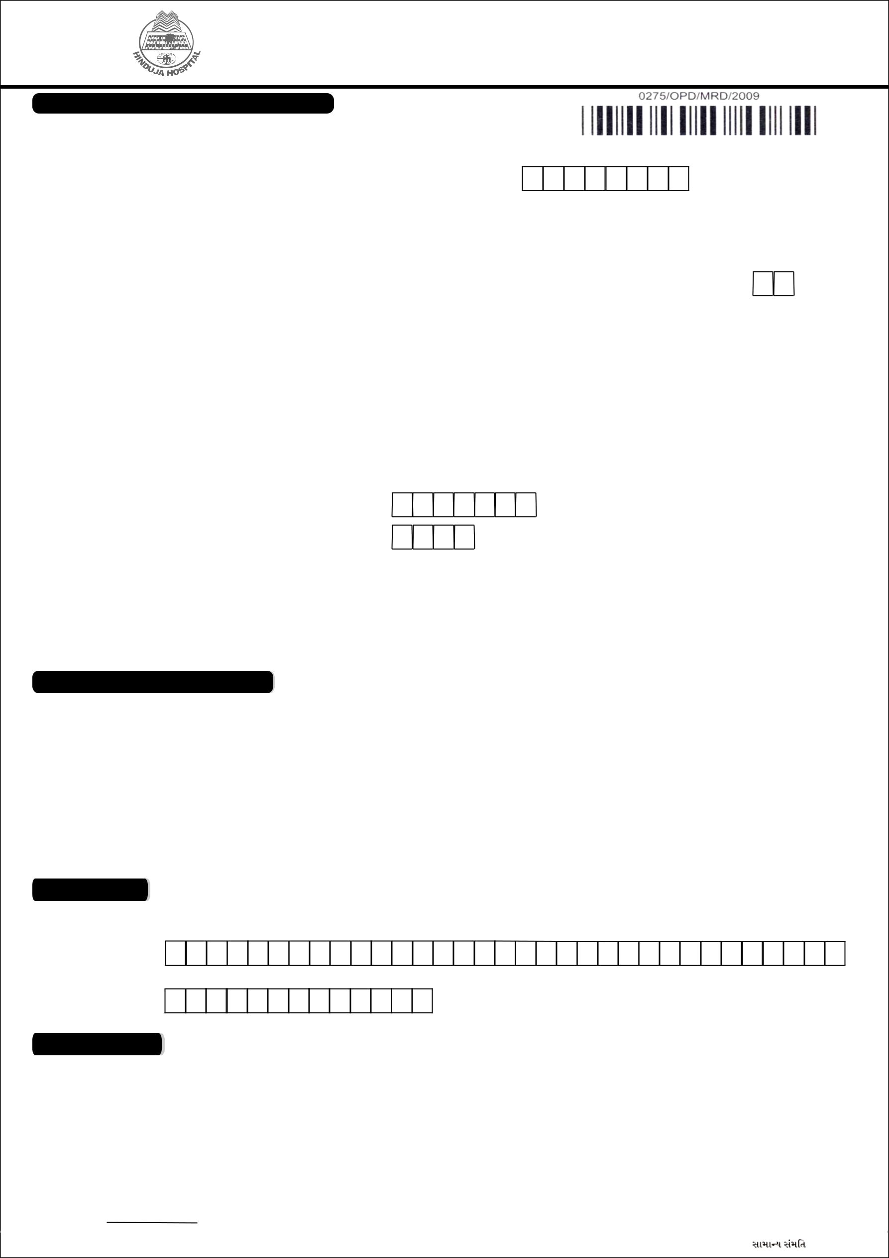
P. D. HINDUJA NATIONAL HOSPITAL AND MEDICAL RESEARCH CENTRE

(Established and managed by the National Health & Education Society)

Veer Savarkar Marg, Mahim, Mumbai- 400 016. Tel: 2444 9199, 2445 1515, 2445 2222 Fax-2444 9151

NEW PATIENT REGISTRATION FORM

(To be filled in English with Black ink in Capital Letters)

If the patient has a Hinduja Hospital (HH) number, please DO NOT fill this form. Please provide this number at the counter or kindly enquire

Date | D | D |  | M | M |  | 2 | 0 | Y | Y | HH No.:

(To be filled by Hospital staff)

 |  | TITLE (Mr./Ms./Dr.etc) |  |  |  |  |  |  |  |  |  |  |  | LAST (SURNAME) |  |  |  |  |  |  |  |  |  |  |  |  |  |  |  |  |  |  | FIRST NAME |  |  |  |  |  |  |  |  |  |  |  |  |  |  |  |  | MIDDLE NAME
Name
Date of Birth |  | D | D |  |  |  | M |  | M |  |  |  |  |  | Y |  | Y |  | Y |  | Y |  |  |  |  |  |  |  |  |  |  |  | Age: |  |  |  |  |  |  |  |  | Years |  |  |  |  |  |  |  | Months |  |  |  |  | Days
Marital Status |  |  | Married |  |  |  |  |  |  |  |  |  |  |  | Single |  |  |  |  |  |  |  |  |  |  |  | Widowed |  |  |  |  |  |  |  |  |  |  | Divorced
Gender |  |  | Male |  |  |  |  |  |  |  |  |  |  |  | Female |  |  |  |  |  |  |  |  |  |  |  | Others
Occupation |  |  |  |  |  |  |  |  |  |  |  |  |  |  |  |  |  |  |  |  |  |  |  |  |  |  |  |  |  |  | Religion:
Resi. Address
City / Town |  |  |  |  |  |  |  |  |  |  |  |  |  |  |  |  |  |  |  |  |  |  |  |  |  |  |  |  |  |  |  | Pin / Zip Code:
State |  |  |  |  |  |  |  |  |  |  |  |  |  |  |  |  |  |  |  |  |  |  |  |  |  |  |  |  |  |  |  |  |  |  |  |  | Country :
Nationality
 |  |  |  |  |  |  |  |  |  |  |  |  |  |  |  |  |  |  |  |  |  |  |  |  |  |  |  |  |  |  |  | Office :
Tel. No.(Res.)
 |  | (STD/ISD Code) |  |  |  |  |  |  |  |  |  |  |  |  |  |  |  |  |  |  |  |  |  |  |  |  |  |  |  |  |  |  |  |  |  |  |  | (STD/ISD Code)
Mobile 1 |  |  |  |  |  |  |  |  |  |  |  |  |  |  |  |  |  |  |  |  |  |  |  |  |  |  |  |  |  |  | Mobile 2 :
Email-Id
Responsible Person / Kin Details
Relation |  |  | Father |  |  |  |  |  |  |  |  |  | Mother |  |  |  |  |  |  |  | Husband |  |  |  |  |  |  |  |  |  |  | Wife |  |  |  |  |  | Other
 |  | TITLE (Mr./Ms./Dr.etc) |  |  |  |  |  |  |  |  |  |  |  | LAST (SURNAME) |  |  |  |  |  |  |  |  |  |  |  |  |  |  |  |  |  |  | FIRST NAME |  |  |  |  |  |  |  |  |  |  |  |  |  |  |  |  | MIDDLE NAME
Name
Contact No.
Emergency
Contact No.
Doctor’s Details
Doctor’s Name

Referring Doctor’s

Name

Referring Doctor’s

Contact Number

General Consent

- I/We agree for the patient to undergo examination, investigation & treatment as decided by the hospital & also to abide by its schedule of charges, rules & regulation. (available at registration counter)

- I authorize Mr./ Ms. _____________________________________ to take decision on my behalf in case of my inability to do so due to associated medical condition.
- I understand that I have disclosed my clinical history & other relevant information to the healthcare provider team required for the management of my disease.
- I am fully aware that the medical treatment may be extended beyond the expected period at the discretion of the doctor.
- I understand my medical record will be destroyed 3 years after my last visit to this hospital.
- If my financial credit status is disputed by credit/insurance company/TPA, I undertake to settle the final bill on the date of discharge. I also undertake to make payment against interim bills raised within stipulated time.
- I certify that I read above & understand the contents. I further state that I have been given an opportunity to ask questions which have been answered fully & to my satisfaction.

Signature | Patient: |  | Responsible Person:
HH CONFIDENTIAL: |  |  | _{PTO for:} saaQaarNa sahmaitÀ sava-saamaanya saMmait

